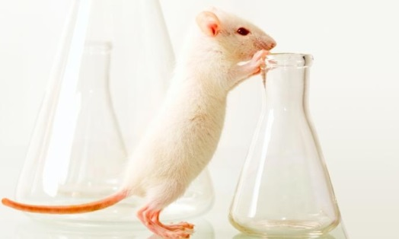
MOUSE Lab Portfolio Project Name:
Your will be conducting with your mouse. For each question, you will be expected create a procedure, perform test, collect data and write a CER summarizing results. When you are finished,
Portfolio will include:
- Cover Sheet (this could include a photo of your mouse)
- INTRODUCTION (1 page)
  - Research the history of mice as model organisms.
    - How long have they been used?
    - Why are they used so frequently?
    - Research and describe a human disease that is studied using mice as a model. What has been discovered through this research?
    - What regulations must scientists comply with when they use mice?
  - Explain the 3 “R”s of animal research. Explain how the 3 Rs can be applied to research with mice.
  - What Bioethical principles are most relevant to animal research? Explain the principle and why it applies to animal research.
  - Describe your mouse- include any pertinent information such as color, weight changes, name, and general behavior you have observed.
- CERs Choose 5 of your 8 labs to turn into a CER.
  - (Follow the format on the back of this sheet)

- Create your own question CER
  - You and your team will come up with a question on your own you would like to test, and then run the test with your mouse. Describe your results in the CER format you used for the other labs.
- Summary (1 page)
  - What did you learn about your mouse? What surprised you? Explain Duties-based and Outcome-based ethics and how they apply to animal research. What is your personal stance? Duties-based or outcome-based?
  - Critique your team designed mouse experiment using the article:
Experimental Design: Top Four Strategies for Reproducible Mouse Research. Guidelines number 2 & 3 pertain to our experiments. After reading through the guidelines, what additional controls would your team need to implement to improve your experiment? Were any of our experiments valid?
7 TOTAL CERs (6 for the provided questions, 1 for YOUR group’s question)

QUESTION:
SUMMARY OF THE PROCEDURE: Describe/explain your protocol (you can include a photo if you want), number of trials, and how you collected your data. This should be brief!
CLAIM: Answer the question
EVIDENCE: Data Tables and Graphs
Graphs should include a narrative (explanation of what the graph shows). Data tables and graphs should have titles (example: Figure 1: Time for mouse to find platform in swimming trials)
REASONING: Describe what your results are. How does your evidence support your claim? Refer to your graph(s). Use specific numbers in your answer! Why did the mouse behave the way that it did?

