Biology
CLASS COPY-Answer questions in your notebook or on the digital copy provided.
Unit 1-Ecology
Flower and Bee Ecology
Using Dissecting and Light Microscopes

Essential Questions:
How do tools such as microscopes help us understand the living world?
How are living things related to one another?
How do humans impact ‘nature?’ How are jobs and the human economy dependent on ‘nature?’

Discuss the following questions with your partner/group. Use your lovely new (new?) textbooks and/or the internet to answer the following questions.

FLOWERS:
- What is the function of a flower? Why do plants have flowers? How long have flowers been a part of life on Earth-how old are flowers?

- Describe or draw at least 3 of the various flowers from the classroom samples. Why do you think they are different? (hint: think about color, shape, size, etc.)

- Use the dissecting microscope to view the flower. The dissecting microscope has TWO eyepieces and is only used to magnify larger objects.

- What do you notice about the flowers WITH the microscope, that you could not see before with just ‘naked eye?

Show your instructor the view in your microscope. Get Initials Here_____________________
Flower Dissection:
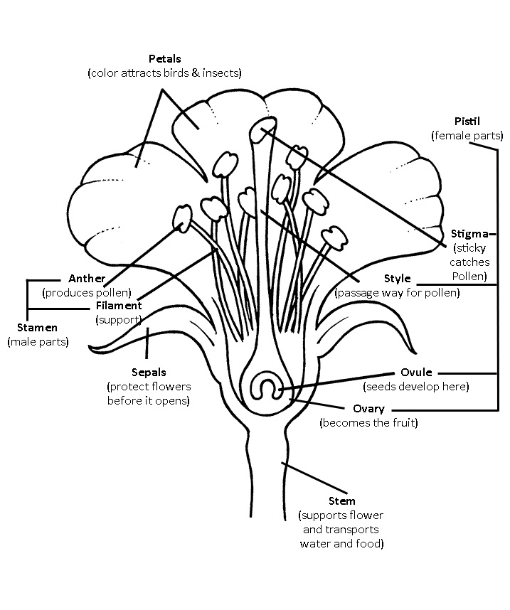
- Using the notecard and tape provided, take apart the flower using the forceps tool. Identify as many flower structures as you can. Tape and label the structures on your notecards. Use the diagrams to help you.

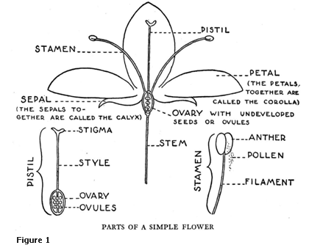

BEES:
- Choose a bee to examine. Use the dissecting microscope to take a close look at the bee. What structures can you identify? (examples: abdomen, antenna, eyes, head, legs, mandible, proboscis, pollen basket, rakes and combs, stinger)

- What type of relationship do bees and flowers have? Are they competitors?

- Is there any pollen on your bee? If so, where is it? How does the bee benefit from the pollen?

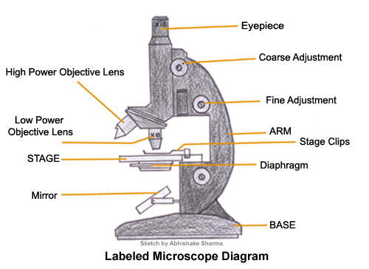
- Where is pollen located on the flower? What is the function of pollen for the flower? What is the function of pollen for the bee?

- Observe a ‘yellow jacket’ wasp. How are
they similar/different?

Using the Light Microscope:

Prepare a wet-mount slide of pollen from the flowers provided.
- First, place a drop of water on a slide.
- Next, use a clean toothpick to remove pollen from the flower.
- Gently mix the toothpick and pollen in the water drop.
- Apply a cover slip.
- Using the LOW power objective, focus on a pollen grain. How many times is the pollen grain magnified? ________eyepiece x__________Objective= ____________ magnification
Use the COARSE (larger knob) focus first to locate the pollen grains. Next use the FINE (smaller knob) focus to make the image even clearer.
Draw the pollen here:

- Using the MEDIUM power objective, again, focus on the same pollen grain. To do this, make sure that the pollen grain is in the center of your view before changing objectives. How many times in the pollen grain magnified? ________eyepiece x__________Objective= ____________magnification
Draw the pollen here:

- Using the HIGH power objective, focus on the same pollen grain. To do this, make sure that the pollen grain is in the center of your view before changing objectives. How many times in the pollen grain magnified? ________eyepiece x__________Objective= ____________
Draw the pollen here:

Show your instructor the view in your microscope. Get Initials Here_____________________

REMEMBER!!! You will write down your thoughts on questions below in your NOTEBOOK;
NOT ON THIS REUSABLE HANDOUT!!!

General Questions. Guess. Ask your lab mates!:
  - What do bees eat (and who eats them)?
  - What “jobs” do bees perform (for the colony and other organisms)?
  - How do humans interact with bees?
  - Do flowers compete for the attention of bees?
  - Do bees compete for flowers?

Research online:
- What is “Colony Collapse Disorder”? Why is this important to humans? What is apparently the cause?

Apply the following vocabulary terms below to the bees and/or flowers.

Use book and/or internet.

NOTE! THE QUESTIONS BELOW ARE A QUALITY OVERVIEW OF ENTIRE FIRST UNIT. START LEARNING
NOW AND REAP THE REWARDS ON FIRST TEST IN A MONTH!

- What is the habitat of a bee?
- What abiotic and biotic factors affect bees and/or flowers?
- What is the niche of the bee?
- Are bees producers? Are flowers producers?
- Are bee consumers? Are flowers consumers?
- Is the bee a predator? Does the bee have any predators?
- What is the scientific term for the relationship between bees and the plants whose flowers they pollinate? Hint: it is not parasite, nor competitor. It is like ‘Nemo’ and anemone in Finding Nemo!
- Are yellow jackets and bees at the same level, ecologically?? What is a trophic level?
Guess what trophic levels bees and yellow jackets are at.
- Draw the food web of the honey bee. What is the genus and species name of the honey bee?
Fancy names like this and like Homo sapiens are called Latin names or Sci. names.
- Guess how many different species of bee are found in North America? Now, look up an answer-were you close?
- How many sunflowers do you think could grow in a 1 meter square garden bed? Why is the number NOT infinite? How is this related to carrying capacity?
- What’s the difference between a population and community, and an ecosystem?
- If you were a political leader with tremendous power, what would you do to ensure the continued survival of honey bees and other pollinators?
- Curiosity is the fuel of science. What more would you like to know about bees and pollination?

